

Assignment - 1

Name: Adil Khan
Roll No: 2610-4011
Section: BS-AI
Subject: Web Engineering

Question no 1:
Index.html:
<!DOCTYPE html>
<html lang="en">
<head>
<meta charset="UTF-8">
<meta name="viewport" content="width=device-width, initial-scale=1">
<title>Sports Gala Trials Booking</title>
<link rel="stylesheet" href="styles.css">
</head>
<body>
<header class="site-header">
<h1>Sports Gala Trials</h1>
<nav aria-label="Main navigation">
<a href="#trials">Trials</a>
<a href="#booking">Book a Slot</a>
</nav>
</header>

<main class="layout">
<section id="trials" class="table-wrap">
<h2>Available Trials</h2>
<table>
<caption>Sports Gala trial schedule</caption>
<thead>
<tr>
<th scope="col">Sport</th>
<th scope="col">Day</th>
<th scope="col">Ground</th>
<th scope="col">Slots</th>
</tr>
</thead>
<tbody>
<tr><td>Cricket Trials</td><td>Thursday</td><td>Main Ground</td><td>30</td></tr>
<tr><td>Badminton Trials</td><td>Friday</td><td>Indoor Hall</td><td>16</td></tr>
<tr><td>Athletics Trials</td><td>Saturday</td><td>Track Field</td><td>60</td></tr>
</tbody>
</table>
</section>

<section id="booking" class="form-wrap">
<h2>Book a Slot</h2>
<form id="bookingForm" novalidate>
<div class="field">
<label for="fullName">Full Name</label>
<input type="text" id="fullName" name="fullName">
<span class="error" id="nameError"></span>
</div>

<div class="field">
<label for="email">Email</label>
<input type="email" id="email" name="email">
<span class="error" id="emailError"></span>
</div>

<div class="field">
<label for="sport">Sport</label>
<select id="sport" name="sport">
<option value="">-- Select a sport --</option>
<option value="Cricket Trials">Cricket Trials</option>
<option value="Badminton Trials">Badminton Trials</option>
<option value="Athletics Trials">Athletics Trials</option>
</select>
<span class="error" id="sportError"></span>
</div>

<button type="submit">Book</button>
</form>
<p id="status" role="status"></p>
</section>
</main>

<footer class="site-footer">
<p>&copy; 2026 University Sports Office</p>
</footer>
<script src="script.js"></script>
</body>
</html>

Styles.css:
:root {
--primary: #1d4ed8;
--primary-dark: #1e3a8a;
--bg: #f3f4f6;
--surface: #ffffff;
--text: #111827;
--error: #b91c1c;
--success: #15803d;
--border: #d1d5db;
}

* { box-sizing: border-box; }

body {
margin: 0;
font-family: Arial, sans-serif;
background: var(--bg);
color: var(--text);
}

/* Header: Flexbox */
.site-header {
display: flex;
justify-content: space-between;
align-items: center;
padding: 1rem 2rem;
background: var(--primary);
color: #fff;
}
.site-header h1 { margin: 0; font-size: 1.5rem; }
nav { display: flex; gap: 1.25rem; }
nav a { color: #fff; text-decoration: none; }
nav a:hover, nav a:focus { text-decoration: underline; }

/* Main: Grid, table wider than form */
.layout {
display: grid;
grid-template-columns: 2fr 1fr;
gap: 2rem;
padding: 2rem;
}

.table-wrap, .form-wrap {
background: var(--surface);
padding: 1.25rem;
border-radius: 8px;
}

table { width: 100%; border-collapse: collapse; }
caption { font-weight: bold; text-align: left; padding-bottom: .5rem; }
th, td { border: 1px solid var(--border); padding: .6rem; text-align: left; }
th { background: var(--primary-dark); color: #fff; }

.field { margin-bottom: 1rem; display: flex; flex-direction: column; }
label { font-weight: bold; margin-bottom: .25rem; }
input, select { padding: .5rem; border: 1px solid var(--border); border-radius: 4px; }
.error { color: var(--error); font-size: .85rem; min-height: 1em; }

button {
background: var(--primary);
color: #fff;
border: 0;
padding: .6rem 1.2rem;
border-radius: 4px;
cursor: pointer;
}
button:hover, button:focus { background: var(--primary-dark); }

#status { color: var(--success); font-weight: bold; }

.site-footer {
text-align: center;
padding: 1rem;
background: var(--primary-dark);
color: #fff;
}

/* Stack below 700px */
@media (max-width: 700px) {
.layout { grid-template-columns: 1fr; }
.site-header { flex-direction: column; gap: .5rem; }
}

Script.js:
const form = document.getElementById("bookingForm");
const status = document.getElementById("status");

function setError(id, message) {
document.getElementById(id).textContent = message;
}

form.addEventListener("submit", function (event) {
event.preventDefault();

const name = document.getElementById("fullName").value.trim();
const email = document.getElementById("email").value.trim();
const sport = document.getElementById("sport").value;

setError("nameError", "");
setError("emailError", "");
setError("sportError", "");
status.textContent = "";

let valid = true;

if (name === "") {
setError("nameError", "Full name is required.");
valid = false;
}
if (email === "") {
setError("emailError", "Email is required.");
valid = false;
} else if (!email.includes("@")) {
setError("emailError", "Email must contain @.");
valid = false;
}
if (sport === "") {
setError("sportError", "Please select a sport.");
valid = false;
}

if (!valid) return;

status.textContent = `Booked ${name} for ${sport}.`;
form.reset();
});

Output:
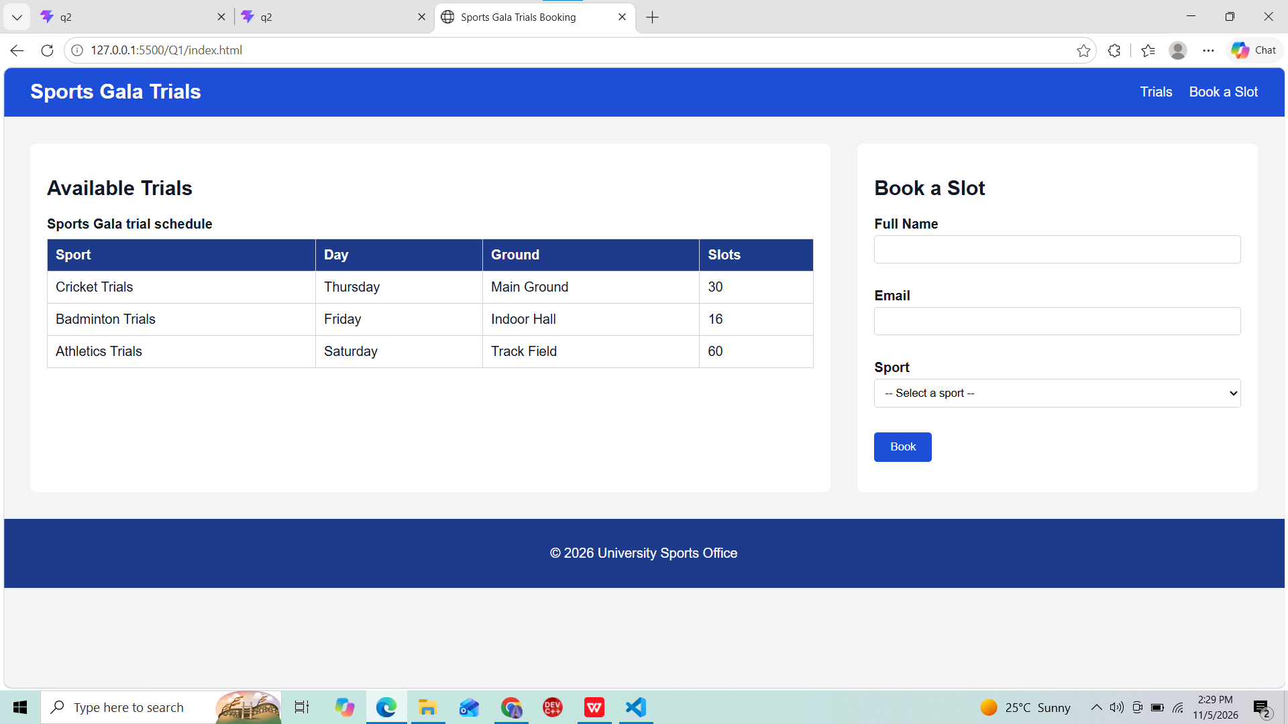

Question no 2:
Types.ts:
export interface Equipment {
id: number;
item: string;
category: string;
}

export const equipmentData: Equipment[] = [
{ id: 1, item: "Yoga Mat", category: "Fitness" },
{ id: 2, item: "Badminton Racket", category: "Sports" },
{ id: 3, item: "Resistance Band", category: "Fitness" },
];

EquipmentRow.tsx:
import type { Equipment } from "./types";

interface EquipmentRowProps {
equipment: Equipment;
checkedOut: boolean;
onToggle: (id: number) => void;
}

function EquipmentRow({ equipment, checkedOut, onToggle }: EquipmentRowProps) {
return (
<tr style={{ backgroundColor: checkedOut ? "#fde68a" : "transparent" }}>
<td>{equipment.id}</td>
<td>{equipment.item}</td>
<td>{equipment.category}</td>
<td>
<button onClick={() => onToggle(equipment.id)}>
{checkedOut ? "Check in" : "Check out"}
</button>
</td>
</tr>
);
}

export default EquipmentRow;

App.tsx:
import { useState } from "react";
import { equipmentData } from "./types";
import EquipmentRow from "./EquipmentRow";

function App() {
const [checkedOutIds, setCheckedOutIds] = useState<number[]>([]);

const handleToggle = (id: number) => {
setCheckedOutIds((prev) =>
prev.includes(id) ? prev.filter((x) => x !== id) : [...prev, id]
);
};

return (
<main>
<h1>Gym Equipment Tracker</h1>
<p>
{checkedOutIds.length} of {equipmentData.length} items checked out.
</p>
<table border={1} cellPadding={8}>
<caption>Gym equipment list</caption>
<thead>
<tr>
<th scope="col">ID</th>
<th scope="col">Item</th>
<th scope="col">Category</th>
<th scope="col">Action</th>
</tr>
</thead>
<tbody>
{equipmentData.map((eq) => (
<EquipmentRow
key={eq.id}
equipment={eq}
checkedOut={checkedOutIds.includes(eq.id)}
onToggle={handleToggle}
/>
))}
</tbody>
</table>
</main>
);
}

export default App;

Output:


